Transformer Capacity Sizing
Norbert Doerry
May 2, 2026
- Introduction
This document discusses determining the power rating and redundancy requirements of three-phase power transformers used to connect two different ac power distribution systems; it does not include transformers that serve a single (or a few loads) such as propulsion motor drives and variable speed drives. Three phase power transformers are often implemented as three single-phase transformers with the primary and secondary windings connected in a delta configuration (Figure 1). If a neutral connection is needed, the primary windings are typically connected in delta and the secondary in wye. In some cases, a three-phase transformer employing a common core is desirable.
Specific requirements and recommendations for power transformers are provided by 46 CFR 111, ABS MVR, and IEEE Std. 45.1.
46 CFR 111 states ….
“If transformers are used to supply the ship's service distribution system required by this subpart for ships and mobile offshore drilling units, there must be at least two installed, independent power transformers. With the largest transformer out of service, the capacity of the remaining units must be sufficient to supply the ship service loads.”
ABS MVR states:
“Where transformers and/or converters form a part of the vessel’s electrical system supplying to essential services and services necessary for minimum comfortable conditions of habitability, as defined in 4-8-1/7.3.3 and 4-8-1/7.3.4, the number and capacity of the transformers and/or converters is to be such that, with any one transformer or converter, or any one single phase of a transformer, out of service, the remaining transformers and/or converters or remaining phases of the transformer are capable of supplying power to these loads under normal seagoing conditions.”
IEEE Std. 45.1 states:
“The simultaneous paralleling of the primaries and the secondaries of two or more transformers is not recommended unless provisions are provided to limit circulating currents. These circulating currents should be included in load flow analyses and in calculating the required current ratings of switchgear and cables.”
“Power conversion equipment and transformers should have a power rating sufficient to satisfy the worst case anticipated load including margin and service life allowance.”
“Single-phase transformers are normally rated in kilovolt-amperes (megavolt-amperes) by multiplying the open-circuit voltage of the secondary by the full-load current, even though these two conditions do not happen at the same time. Hence, the actual number of kilovolt-amperes delivered by the transformer has to take into account the regulation of the transformer. Similarly, three-phase transformers are normally rated in kilovolt-amperes (megavolt-amperes) by multiplying the open-circuit line-to-line voltage by the full-load current and the square root of 3.”
“The calculation of the worst-case anticipated load should account for the impact of cycling loads. Additionally, the ability of the power conversion and transformers to provide in-rush current to load equipment and to provide adequate, but not too much, fault current to enable proper coordination of circuit breakers should be evaluated.”
“Dry type transformers are recommended for shipboard applications.”
“When supplying nonlinear loads, transformers experience losses due to harmonic and other non fundamental frequency components of the current waveform. Resonance between transformer winding inductance and supply capacitance is a possibility that can cause additional losses. Also, there is the potential for laminated core vibrations that can generate unwanted audible noise. When supplying nonlinear loads where the ITHD is expected to be excessive, transformers should be de-rated.”
“K-factor” calculations are a common method used when designing and selecting transformers for nonlinear loads. K-factor is a measure of the additional losses that harmonic currents create within the transformer. IEEE and IEC (IEEE Std C57.12.00, IEEE Std C57.12.90, or IEC 60076-1) have standards to de-rate transformers, and it is the responsibility of the cognizant engineer to determine the appropriate standard to use. Selecting a transformer with a K-factor rating no less than the K-factor rating of its load will help ensure that the transformer will not overheat due to harmonics. This will, however, have little or no effect in reducing the voltage distortion introduced by the transformer due to the harmonic voltage drops across its impedance. To reduce voltage distortion, harmonic mitigating transformers should be considered.”
“The number and rating of transformers supplying services and systems essential to the safety or propulsion of the ship should have sufficient capacity to ensure the operation of those services and systems even when one transformer is out of service. Transformers should be either the three-phase type or the single-phase type, suitable for connection in a three-phase bank. All distribution and control transformers should have isolated primary and secondary windings. Transformers with electrostatic shielding between windings should be used in distribution systems containing nonlinear load devices or other sources of common-mode voltage or common-mode current.”
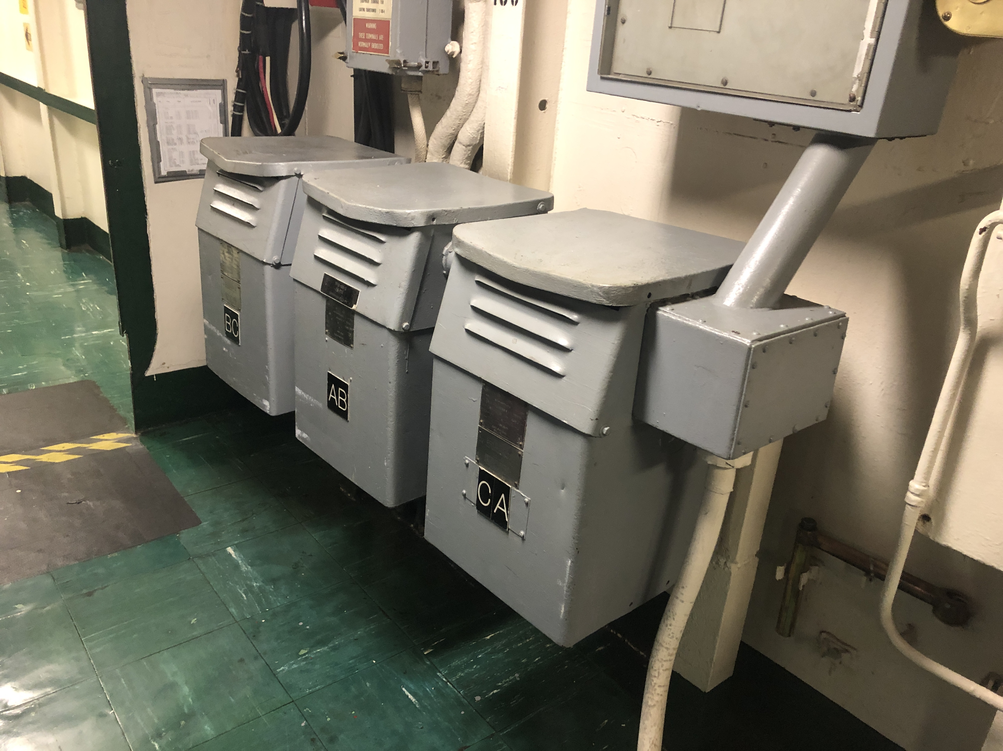
Figure 1: Transformer bank onboard USS Midway CV-41 (photo by Norbert Doerry)
- Considerations
  - Load analysis
The traditional load factor analysis process for calculating the maximum operating load assumes that the variation of load around the mean value is small; the magnitude of each cycling load is assumed small with respect to the sum of all of the load averages. While this is generally true at the total ship level, transformers usually only serve a subset of the ship’s loads. Certain cycling loads may be significant; the traditional load factor analysis may underestimate the required power rating of the power transformer.
The zonal load factor process as described in DPC 310-1 is recommended for calculating the maximum operating load for power transformers if a significant amount of the load served by the transformer is due to cycling loads. Zonal load factors account for the variability in the total load due to having non-constant power loads. The zonal load factor method requires for each load: the load factor for the 24-hour average calculations; the connected load; and the peak load. The zonal load factor method will generally result in a larger operating load as compared to the traditional load factor method.
  - Margin and Service Life Allowance
Margins account for uncertainty in the operating load estimate during the design and construction of a ship; service life allowance accounts for growth in load while the ship is in-service. Margins and service life allowance are applied to the maximum calculated operating load to determine the minimum rating of the transformer. IEEE Std. 45.1 recommends the following margins and SLA:
Detail Design Margin: 5% for existing follow-on designs to 20% for new first-time designs
Construction Margin: 5% for existing follow-on designs to 20% for new first-time designs
SLA: 20% (1% per year for 20 years)
  - Harmonic and common mode currents
If harmonic currents or common mode currents are present, a transformer should be derated as described by IEEE Std. 45.1 to account for the additional heating of these undesirable currents. Harmonic currents and common mode currents are generally produced by loads that employ power electronic converters. Common mode currents are more of a concern if the transformer has a delta primary and a wye secondary where the neutral of the secondary is grounded either directly or through a neutral grounding resistor; the current through the neutral connection results in a circulating current in the delta primary.
  - Survivability
The rating of transformers should account for both normal operation and for cases where additional load is applied via bus transfers from other transformers that are not functioning. In this case, load shedding of lower priority loads may be required to supply all vital loads.
Delta-delta transformers are often fabricated using three single-phase transformers. If one of the transformers is damaged, it can be removed from the circuit and the remaining two transformers may be operated as an open delta transformer. Load on the open-delta transformer should be restricted to about 58% of the full three transformer bank power rating to avoid overloading the remaining two transformers. The design of the delta-delta transformer bank should facilitate the removal of a transformer from the circuit and the safe operation of the remaining two transformers.
  - In-rush current
The in-rush current of large transformers may be greater than can be sustained by generator sets supplying the transformer. In these cases, pre-charge circuitry may be incorporated into the transformer design to reduce the in-rush current. Alternately, employing more, lower rated transformers that are not energized at the same time may reduce the in-rush current to an acceptable level.
  - Fault protection
Transformers with a higher maximum power rating have lower impedances in order to ensure the secondary voltage is not too low at full power. These lower impedances along with the turns ratio of the transformer, can result in fault currents on the distribution system connected to the secondary windings that exceed the interruption capability of available circuit breakers. Reducing the maximum power rating of transformers by employing more of them, may reduce the maximum available fault current on the secondary side of the transformers to a level that can be interrupted by available circuit breakers. See Dalton (2019) for more details.
  - DC current saturation
If a rectifier (non-isolated) is connected to a high resistance grounded distribution system powered by delta-wye transformer with the neutral connected the neutral grounding resistor, then a ground fault on the dc side of the rectifier will likely result in dc currents flowing in each of the phases of the transformer. If the delta-wye transformer is constructed from three single phase transformers or employs a single shell type transformer core, then the dc currents may lead to saturation of the transformer core(s) with large primary currents and low secondary voltages. A delta-wye transformer that employs a core-type three phase core is much less likely to saturate and should be considered. See Doerry (2022) for a description of shell type and core type three phase transformers.
- References
ABS MVR, ABS Rules for Building and Classing Marine Vessels
46 CFR 111 Code of Federal Regulations -- Coast Guard, Department of Homeland Security, Electrical Engineering, Electrical Systems - General Requirements
IEEE Std 45.1, IEEE Recommended Practice for Electrical Installations on Shipboard—Design
DPC 310-1 Electric Power Load Analysis (EPLA) for Surface Ships
Dalton, Thomas, "Power Application Limitations of AC Shipboard Electric Plants for US Navy Ships," presented at ASNE TSS 2019, June 18-20, 2019, Washington DC.
Norbert Doerry, " Shipboard Three-Phase Power Transformer Analysis," Version 1.0, December 10, 2022.

